Wenjie Xu Lab 7

1. What are the SSIDs of the two access points that are issuing most of the beacon frames in this trace?

Answer: The SSIDs of the two access points issuing most of the beacon frames are “30 Munroe St” and “linksys12”.

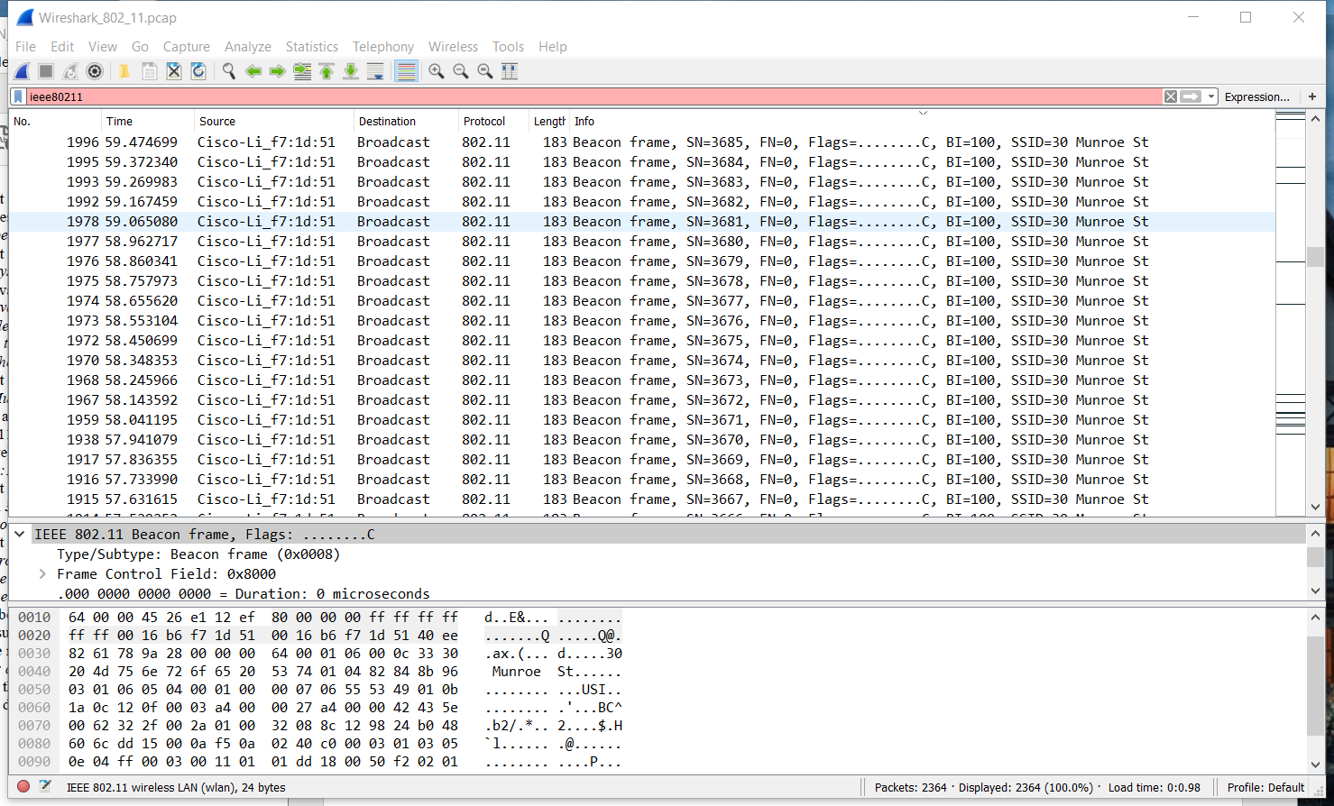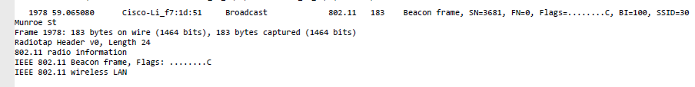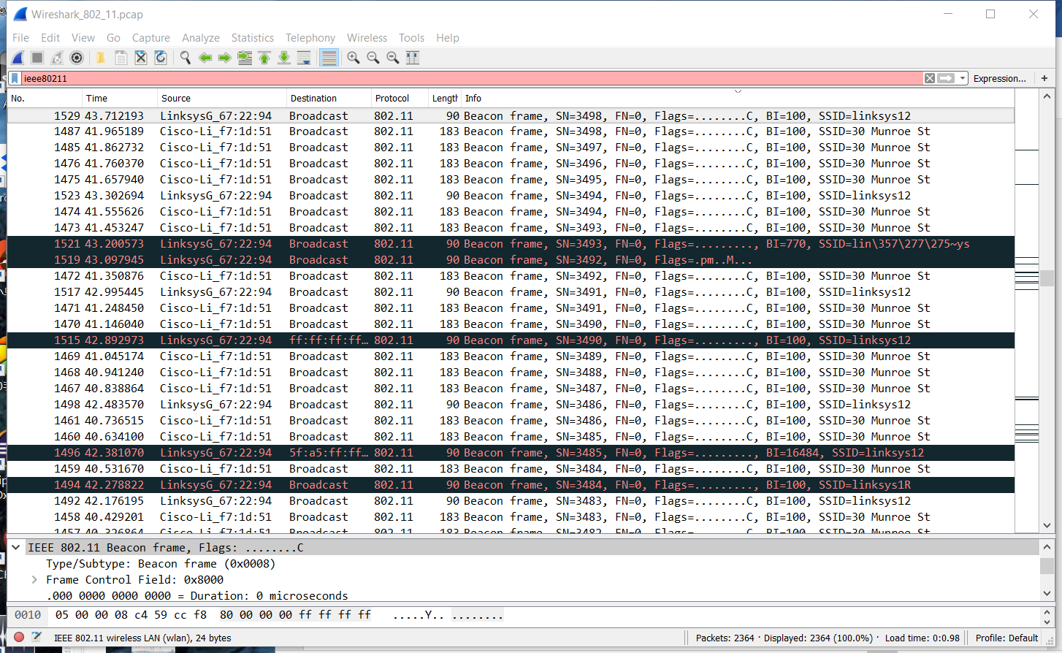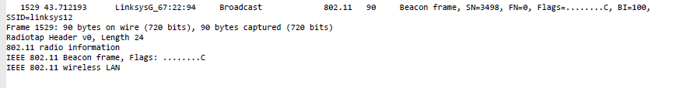

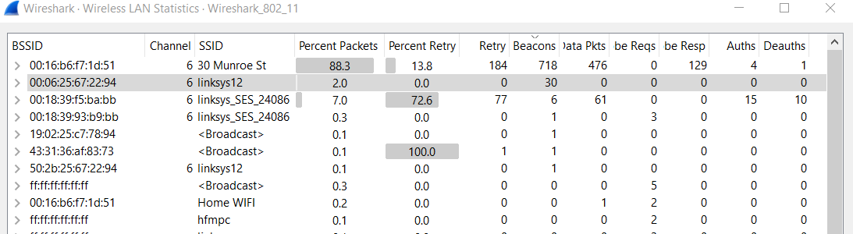

2.What are the intervals of time between the transmissions of the beacon frames the *linksys_ses_24086* access point? From the *30 Munroe St*. access point?

Answer: The intervals for both access points indicate 0.102400 seconds in the Beacon Interval of the 802.11 wireless LAN Management frame.

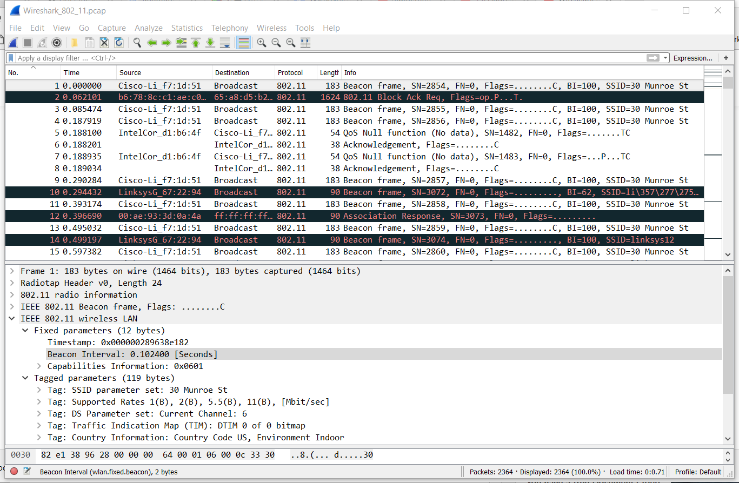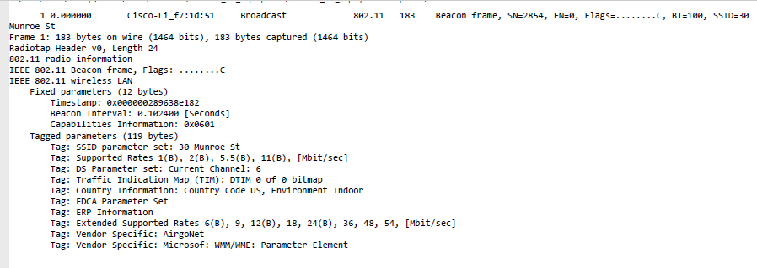

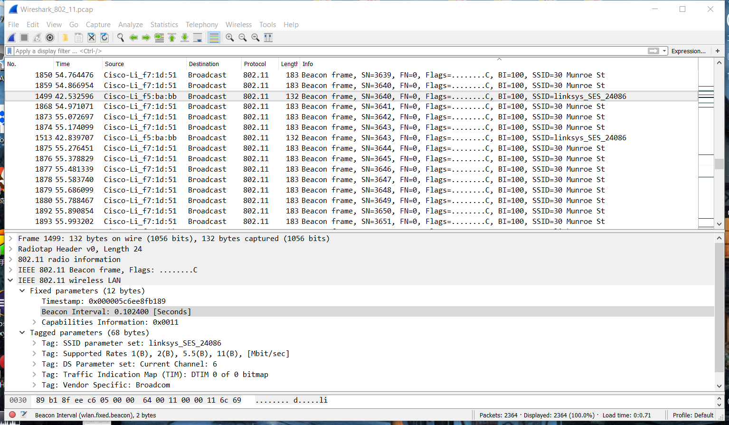

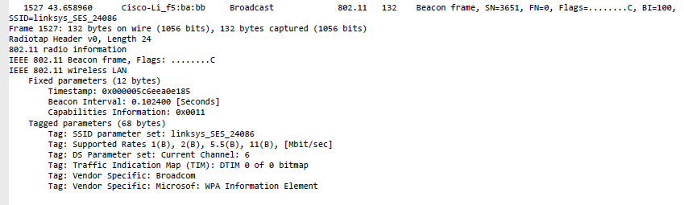

3. What (in hexadecimal notation) is the source MAC address on the beacon frame from *30 Munroe St*?

Answer: The source MAC address on the beacon frame from 30 Munroe St is 00:16:b6:f7:1d:51

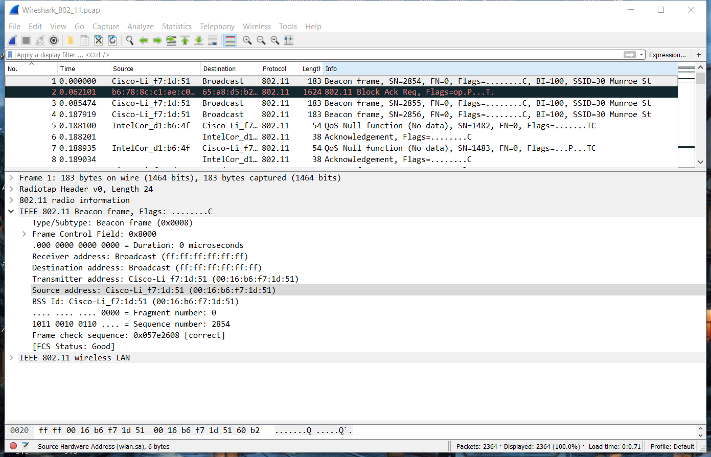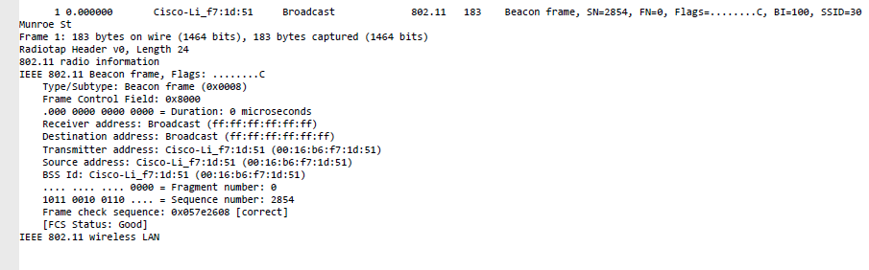

4. What (in hexadecimal notation) is the destination MAC address on the beacon frame from *30 Munroe St*?

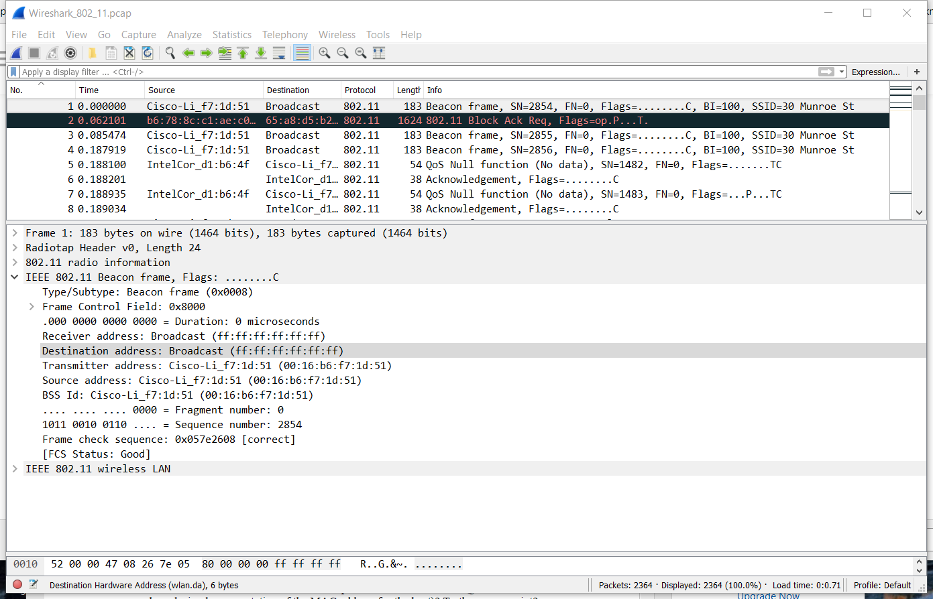Answer: The destination MAC address of the beacon frame 30 Munroe St is ff:ff:ff:ff:ff:ff, the Ethernet broadcast address.

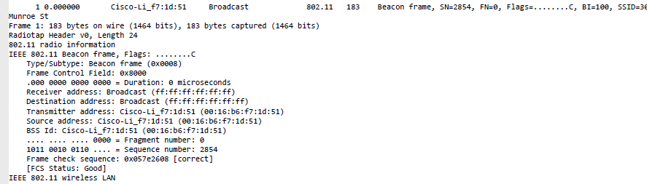

5. What (in hexadecimal notation) is the MAC BSS id on the beacon frame from *30 Munroe St*?

The MAC BSS id on the beacon frame from *30 Munroe St* is 00:16:b6:f7:1d:51.

